**Personal Project- Part 1**

**Adi Shenhav**

**ID: 205798218**

1. The website/application that I will build is an interactive platform connecting BGU student vehicle owners(drivers) and BGU student hitchhikers based on the proximity of their location, final destination of desired ride, and time of registration.
2. UX Requirements
   1. There are two types of users. Drivers looking to find hitch hikers from the BGU community that will join their ride (charging at a reasonable rate). Hitch hikers looking for a trusted and local driver from the BGU community that will charge at a reasonable rate. The app has no monetary function.
   2. In its essence the app is a ride sharing platform. Meaning that the drivers benefit by saving money on gas and the hitchhikers benefit from an easy and comfortable form of transportation.
   3. The service that the app provides to the user is an easy-to-use way of connecting the wants of both types of travelling BGU students. This service eliminates the traditional time-wasting method of WhatsApp/Facebook messaging groups and efficiently locates and assigns ride sharing partners.
   4. The procedure of the service will be as follows:
      1. First the user must authorize the use of his/her geo-location
      2. Next the user must identify as either a driver or a hitchhiker
      3. Hitchhiker:
         1. If the hitchhiker already signed up, they must log in to see if they have a match (check status).
         2. Else the hitchhiker must fill out a form with their personal details, click submit and await results.
      4. Driver:
         1. Driver fills out form and submits awaiting hitchhikers to contact him/her for ride.
         2. Number of seats is updated for every match, once the driver has 0 seats available the driver can no longer be matched to new hitchhikers. If hitchhiker chooses to cancel existing match then number of seats available is updated accordingly.
      5. After each user submits the form, their information is stored in a database. If the user is a hitchhiker than he/she receives a message from the app/website detailing a compatible drivers contact information based on time, proximity, final destination, and number of seats left.
   5. Data needed:
      1. Driver: student email, full name, phone number, final destination, geo-location, number of seats available, timestamp
      2. Hitchhiker: student email, full name, phone number, final destination, geo-location, timestamp, Driver ID
   6. The database structure needed is a mySQL server that coincides with RDBMS format. Meaning there will be a table for drivers and for hitchhikers with their associated attributes. In addition, there will be a table with all BGU emails in order to validate that users using the site are BGU students.
3. UI Specifications
   1. The app/website should be designed with the following key values:
      1. Simplicity/Minimalist Aesthetic- not to overwhelm the user with too many details
      2. Consistency and Standards- graphic elements and terminology are maintained across similar platforms
   2. Visual rules for values
      1. Simplicity/Minimalist Aesthetic- use of one type of font (Calibri), four basic colors (blue, white, green, black), images that correlate to actions/identities such a simple image of a car for drivers and hand waving for hitchhikers.
      2. Consistency and Standards- buttons to submit information, standard location of ‘back’ button or submit button. Empty boxes are used to indicate where the user’s information should be filled.
4. Wireframes
   1. Main Screen
      1. Driver button: opens the Driver Input page(b)
      2. Hitchhiker button: open the Hitchhiker options screen(d)
      3. Allow Location button: once opening the main page this API is opened and is required for the user to continue. When the allow button is pressed the geo-location of this user is saved.
   2. Driver Input- attached to the driver user database + validates email authenticity with BGU email database
      1. All fields are required and added to the driver user database
      2. Number of seats is updated when hitchhiker is assigned to driver or when hitchhiker cancels registration
      3. Back button: takes user back to main screen
      4. Submit button: saves registration and transfers data to driver database
   3. Driver Feedback
   4. Hitchhiker option screen
      1. Log in button: opens log in screen (f)
      2. Sign Up button: opens sign up screen (e)
   5. Hitchhiker Input (Sign Up)- attached to the hitchhiker user database + validates email authenticity with BGU email database
      1. All fields are required
      2. Submit Button: Searches in driver database match based on final location, geo-location and time stamp, opens Hitchhiker feedback screen (g or h) based on data, updates Driver ID field in hitchhiker database.
      3. Back button: opens Hitchhiker option screen
   6. Hitchhiker Input (Log In)- attached to the hitchhiker user database + validates email authenticity with BGU email database + connects to driver userbase
      1. Both fields are required
      2. Check Status button: searches in hitchhiker database if there is a match and opens Hitchhiker feedback screen (g or h) based on data. If there is match then updates Driver ID field in hitchhiker database.
   7. Hitchhiker Feedback- match: based on hitchhiker user attributes and driver database
      1. Cancel Ride button: updates driver number of seats, deletes data from hitchhiker database
   8. Hitchhiker Feedback- no match: based on hitchhiker user attributes and driver database
      1. Restart button: opens Hitchhiker option screen (d)

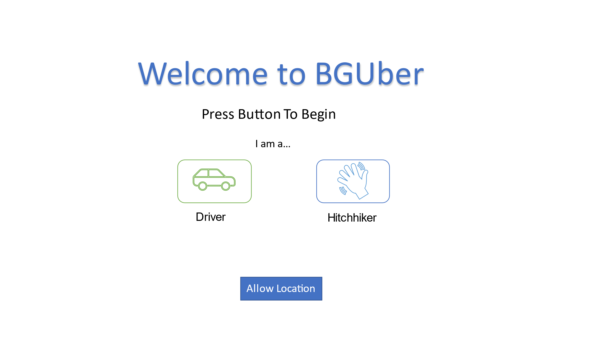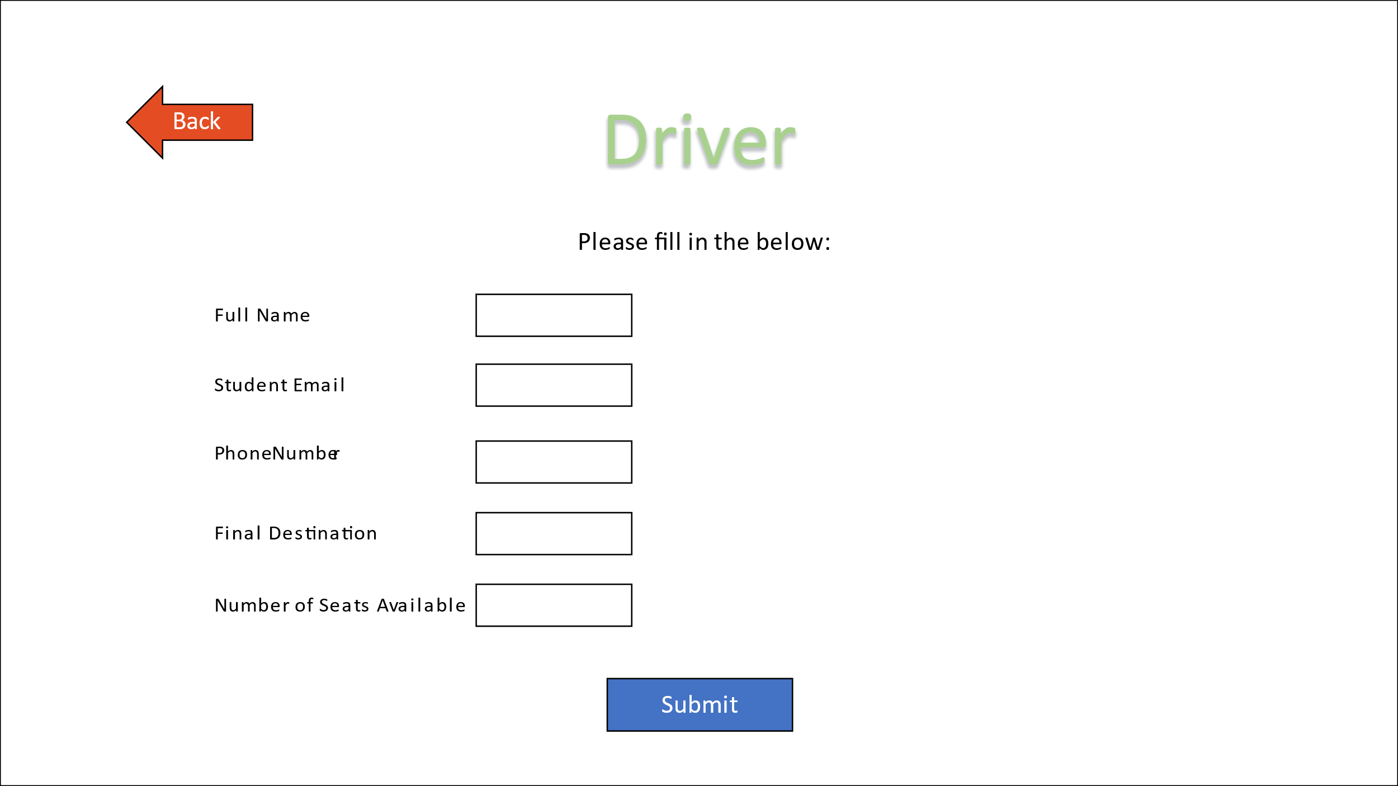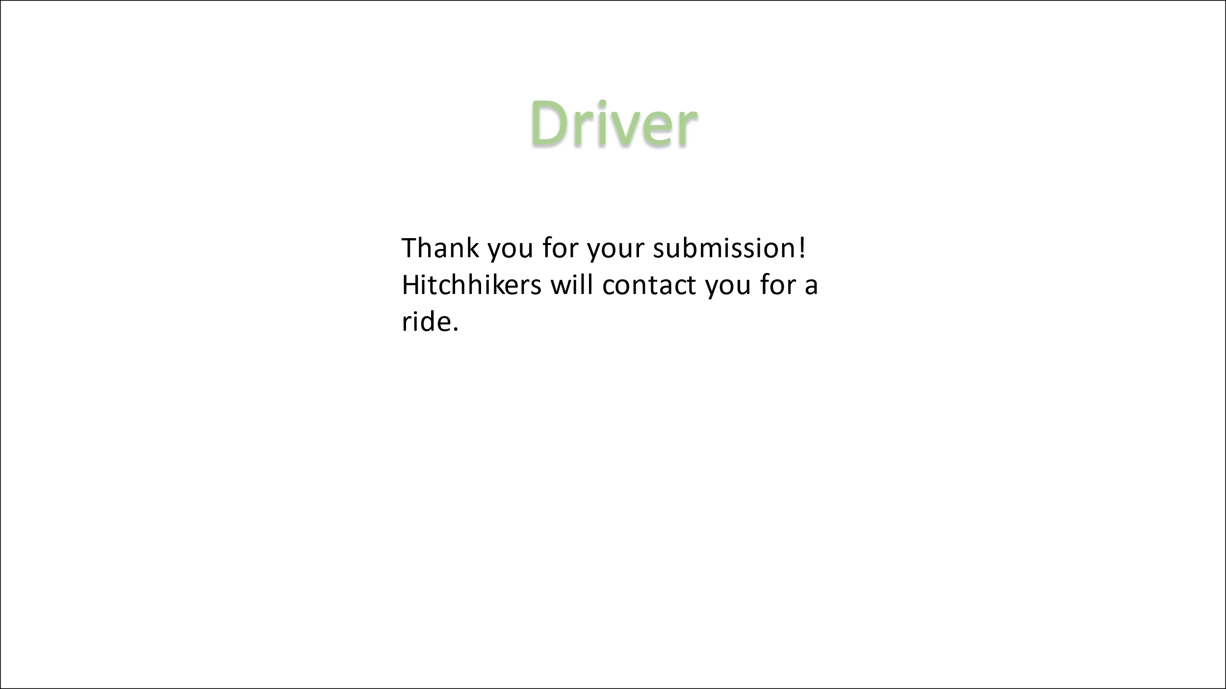

a

b

c

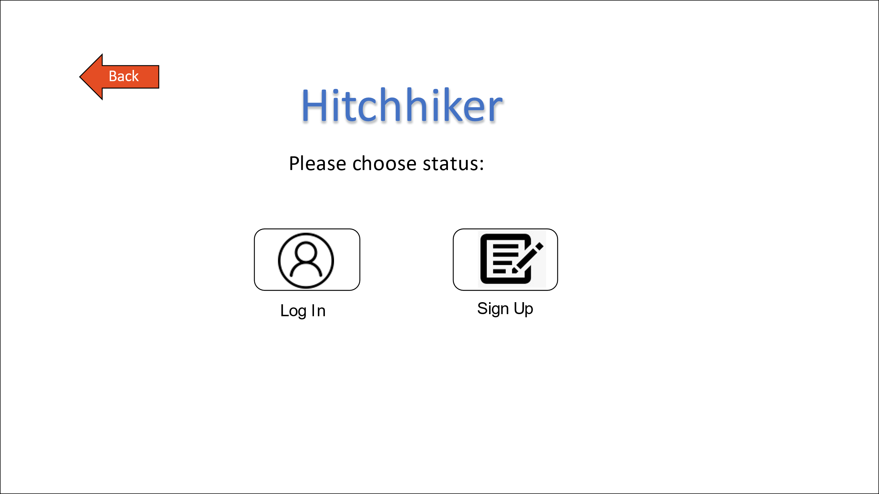 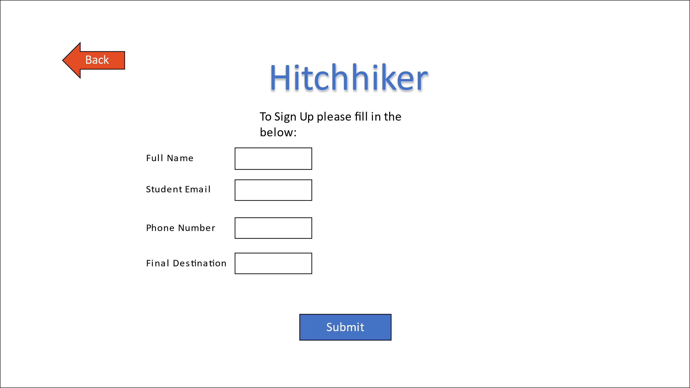 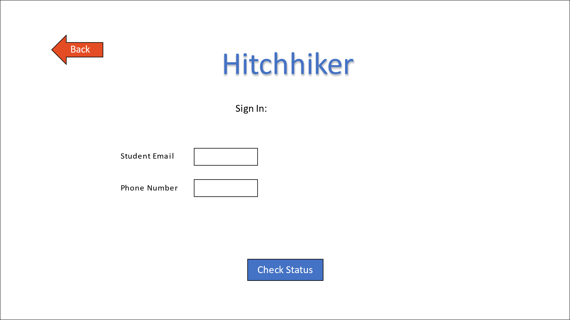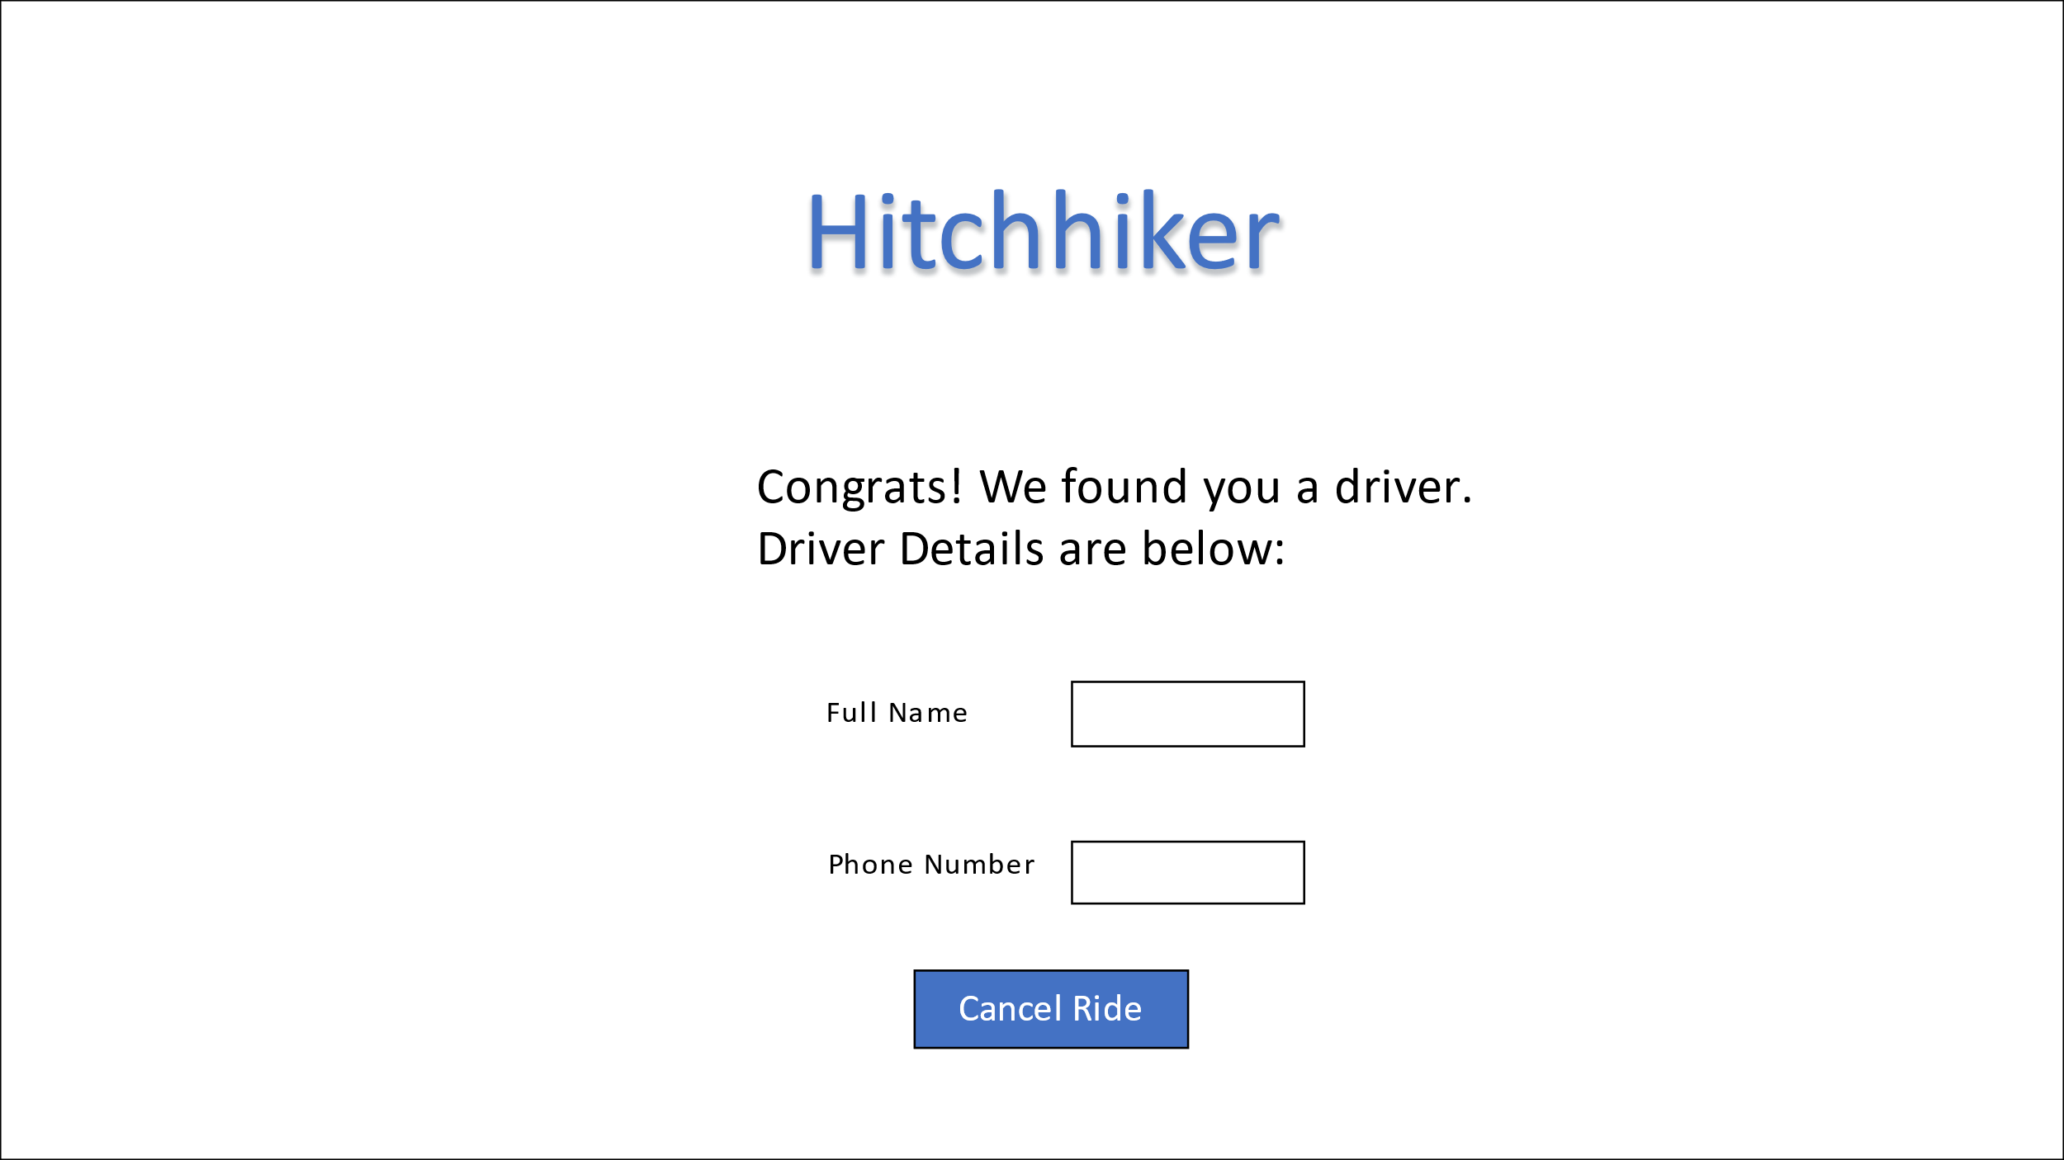 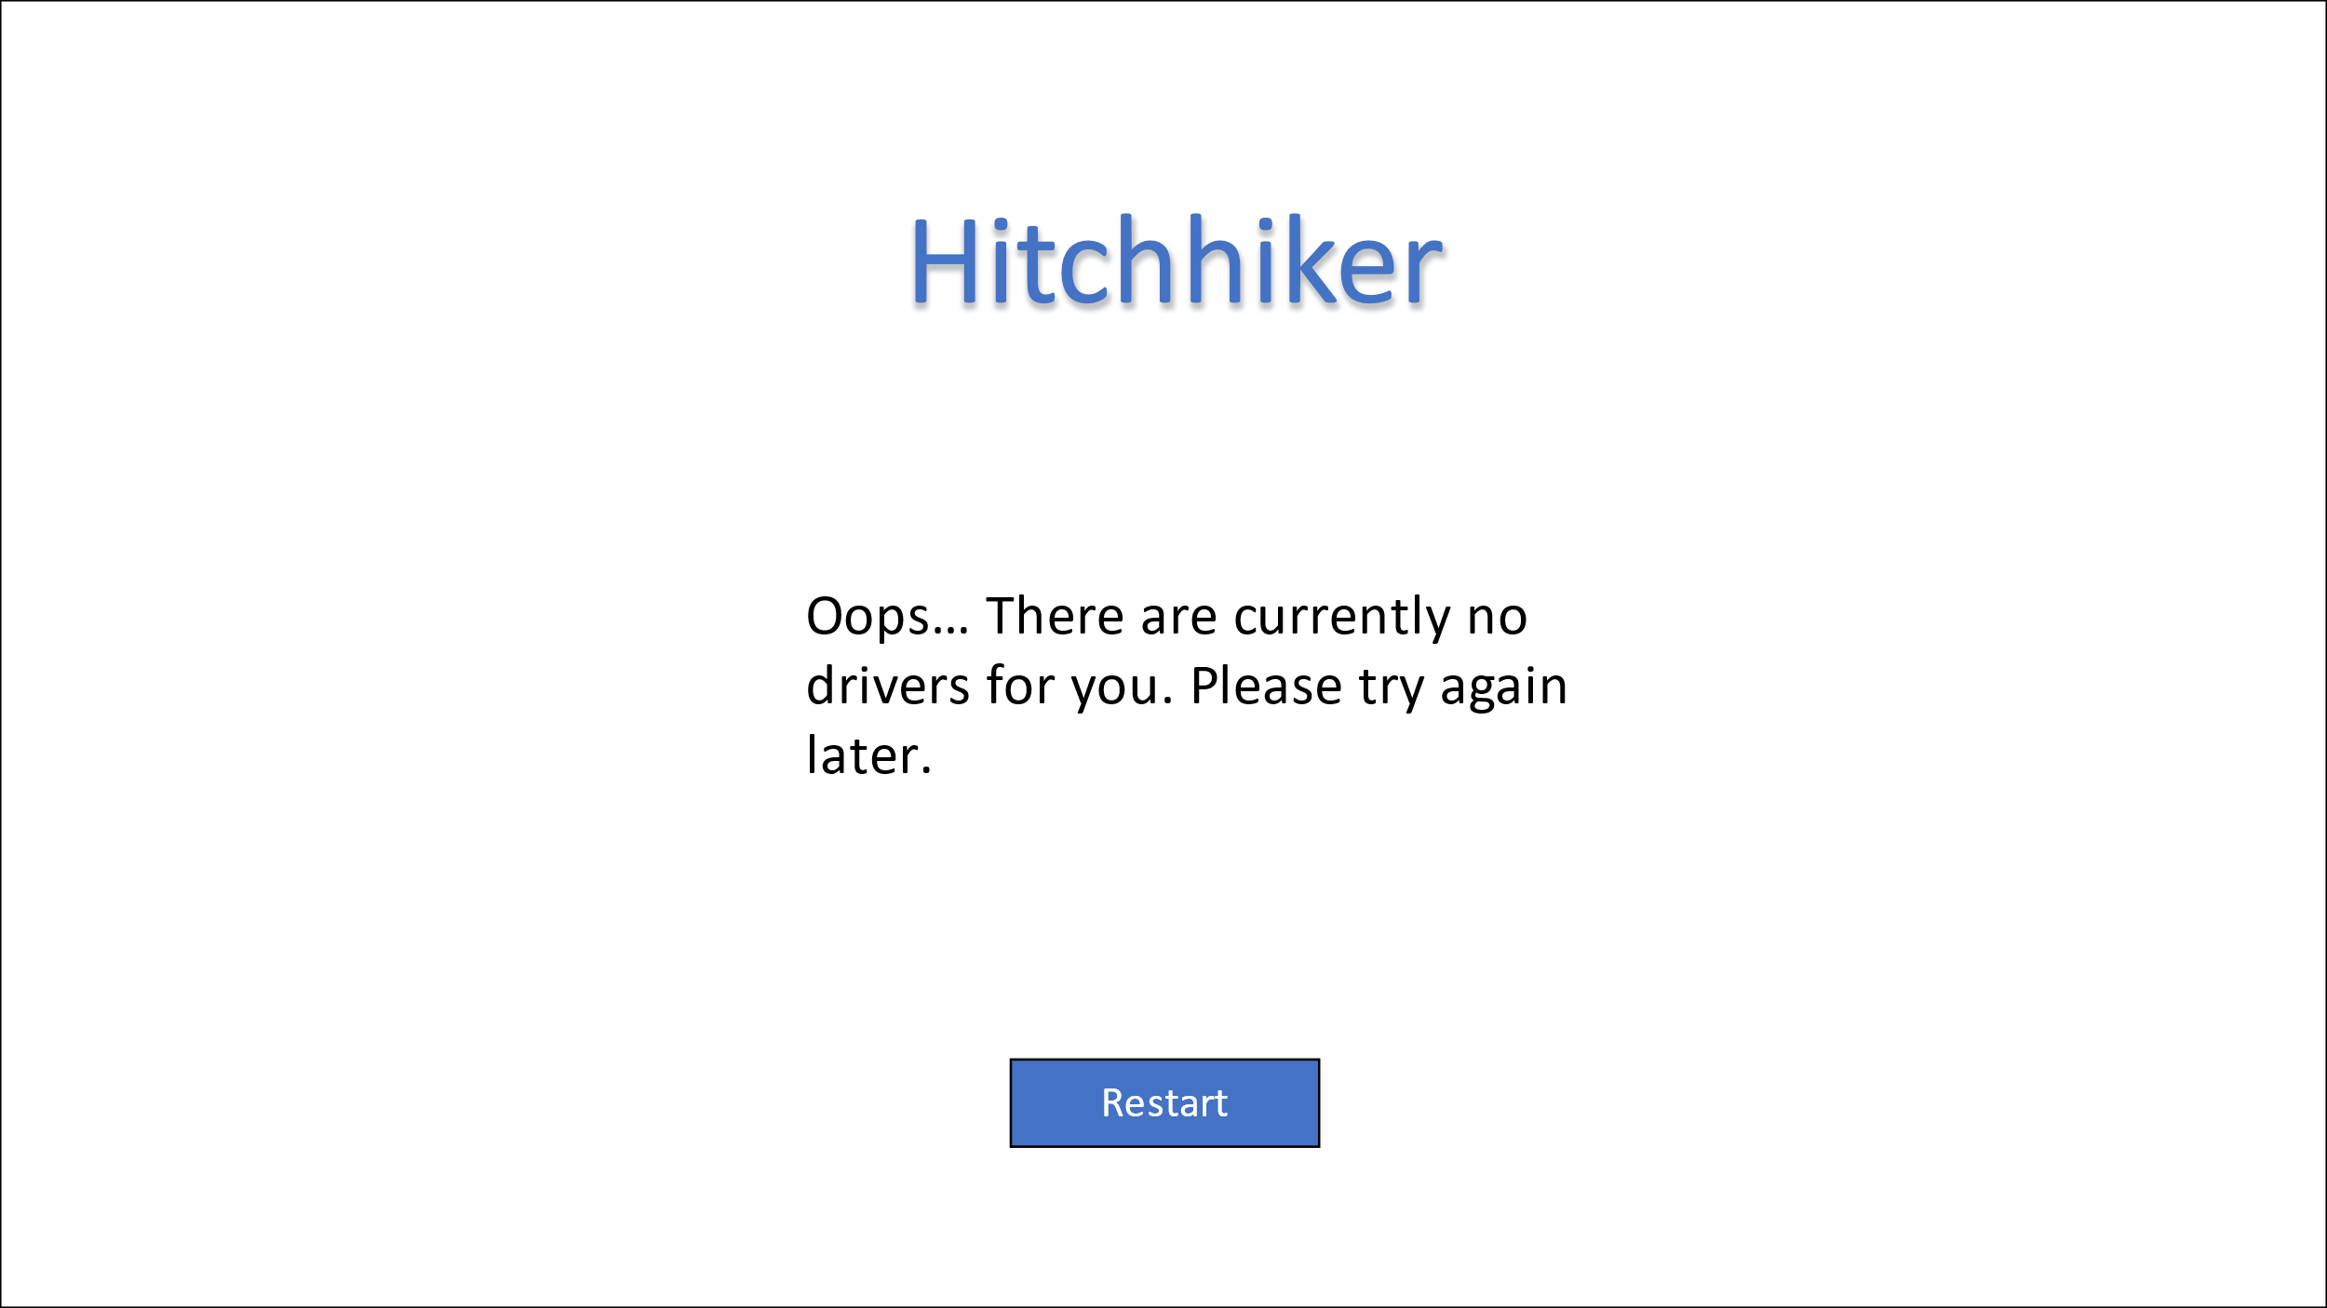

e

d

f

g

h

Assumptions:

* The geo-location of a user is the starting point of the ride for both users
* Hitchhikers are responsible to contact the driver after each match, the driver is a passive user
* Users are matched by a 10 km radius of current location
* Rides have an expiration time of 1 hour
* Validation of student status is done by student email
* The app has no monetary purpose/policy affiliated with its users and rides